Art Gallery Society Event: A Winter Season of Music
A series of concerts presented by the Newcastle Art Gallery Society
Kevin Hunt Trio - An evening of Jazz
Saturday 12 August 2017, 7.30pm
The Kevin Hunt Trio, with Kevin Hunt at the Stuart & Sons studio grand piano will perform a wide program of jazz styles including arrangements by J.S.Bach, Scott Joplin and Duke Ellington along with other composers.
Pianist Kevin Hunt has performed regularly in the Sydney jazz scene since 1979. In 1981 he studied jazz at the Sydney Conservatorium of Music with Don Burrows, Judy Bailey, Paul MacNamara, Roger Frampton, George Golla and others. Since the mid-1980s, Kevin has led his own jazz ensembles specialising in performances of his own compositions as well as classical composers including J S Bach, Maurice Ravel, Claude Debussy, and Leonard Bernstein.
Don Burrow’s intuitive teaching techniques have greatly influenced Kevin’s style, particularly in jazz improvisation. Kevin says he is also influenced by and in awe of the artistry of musicians such as Oscar Peterson, Bill Evans, Keith Jarrett, Bud Powell, and George Shearing. In 2001, Kevin was awarded the Australian Elizabethan Theatre Trust Jazz Scholarship for piano and composition studies in New York City.
Since 2010 Kevin has developed at the Conservatorium the program OUR MUSIC, performing place, listening to Sydney, to collaborate musically with local and regional Aboriginal and Torres Strait Islander musicians.
Kevin teaches jazz studies at the Sydney Conservatorium of Music and has recently completed his PhD entitled Perceptions of the Stuart & Sons piano: realising a creative, active vision.

HOW TO BOOK:
Download the booking form and return via post, email or in person.
POST:Newcastle Art Gallery Society
PO Box 1727 Newcastle NSW 2300
EMAIL:
gallerysociety@ncc.nsw.gov.au
IN PERSON:
At the Gallery Shop (cash or cheque only)
PHONE ENQUIRIES:02 4974 5123 - (please leave a message and we will return your call).

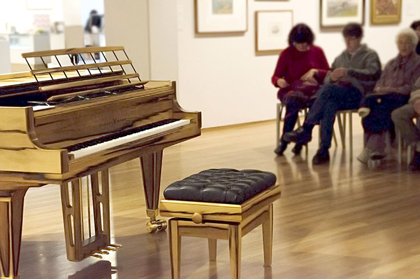
STUART & SONS 'Studio grand piano' 2012 (detail) veneered in Tasmanian blackheart sassafras with 102 keys. Gift of the Newcastle Art Gallery Foundation with the assistance of Lindy and Robert Henderson, John and Valerie Ryan, Les Renfrew Bequest and the Newcastle Art Gallery Society 2013 Newcastle Art Gallery collection

Prices Full Price $55 / Seniors $50 Pensioner/Student $45
Venue Newcastle Art Gallery 1 Laman Street Cooks Hill 2300

