Performing The Jewish Archive - Out Of The Shadows

Aug 7-10th - Kevin Hunt is proud to lead two jazz ensembles of Sydney Conservatorium accompanying two Jewish Cabarets of the 1930s.This presentation of Jazz music in cabaret is part Out of the Shadows: rediscovering Jewish music and theatre funded by Performing the Jewish Archive, a British Arts & Humanities Research Council project. Performing The Jewish Archive - Out Of The Shadows –
Mon7th – Thurs 10th August, 7pm The Sound Lounge, Seymour Centre.
http://music.sydney.edu.au/research/special-research-events/shadows-rediscovering-jewish-music-theatre/

Wed Aug 9th - The Helsinki Stompers accompanies the show ‘Merchants of Helsinki’ The Sound Lounge, Seymour Centre
https://www.seymourcentre.com/events/event/the-merchant-of-helsinki/
This cabaret-revue show from 1930 was written in Yiddish by Jac Weinstein. It follows a tradition of New Year’s revues, dealing with social issues facing the small but tightly knit Jewish community of Helsinki. Like many Jews of this era, the community mostly worked in the garment industry.

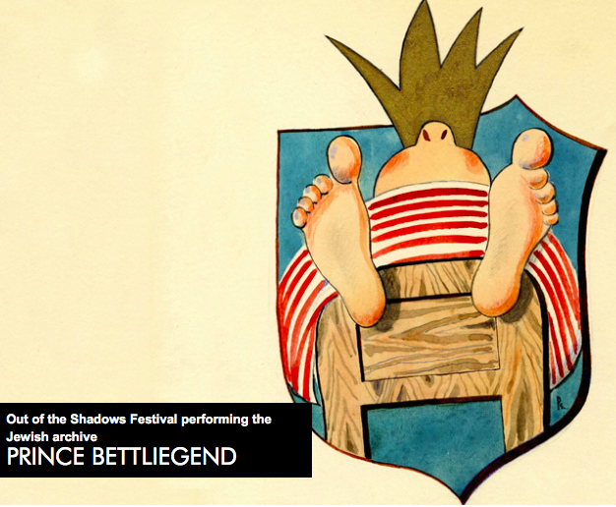

Aug 7, 8, 10 The Jezek Stompers accompanies the show ‘Prinz of Bettliegend’ (The Bedridden prince) The Sound Lounge, Seymour Centre.
https://www.seymourcentre.com/events/event/prince-bettliegend/
This cabaret was written by young Czech-Jewish prisoners in the World War II ghetto at Terezín (in German, Theresienstadt). The music was written by Jaroslav Ježek in the 1920s and 1930s in his position as musical director for the Liberated Theatre (Ozvobozéne Divádlo) in Prague. Ježek’s musical style is concurrent with the hot American jazz styles of the time (with a particular affinity for Gershwin, stride piano and Dixie arrangements), but he had his own idiosyncrasies, informed by Czech tastes. Ježek’s revues were all written for the incomparable comedy duo Jíři Voscovec and Jan Werich (known as J+W), who still remain beloved icons of Czech culture.

